|  |  |  |  |
| --- | --- | --- | --- |
|  | Bansilal Ramnath Agarwal Charitable Trust's  Vishwakarma Institute of Information Technology  **Department of**  **Artificial Intelligence and Data Science** | | |
| Name: Siddhesh Dilip Khairnar | | | |
| Class: SY | Division: B | | Roll No: 272028 |
| Semester: IV | | Academic Year: 2022-2023 | |
| Subject Name & Code: Software Engineering: ADUA22204 | | | |
| Title of Assignment: Use Case Diagram. | | | |
| Date of Performance: 15-02-2023 | | Date of Submission: 04-03-2023 | |

Aim: Assignment 3 – Use Case Diagram.

Problem Statement:Derive the use cases based on the requirements from CPS and draw use case diagram using star UML.

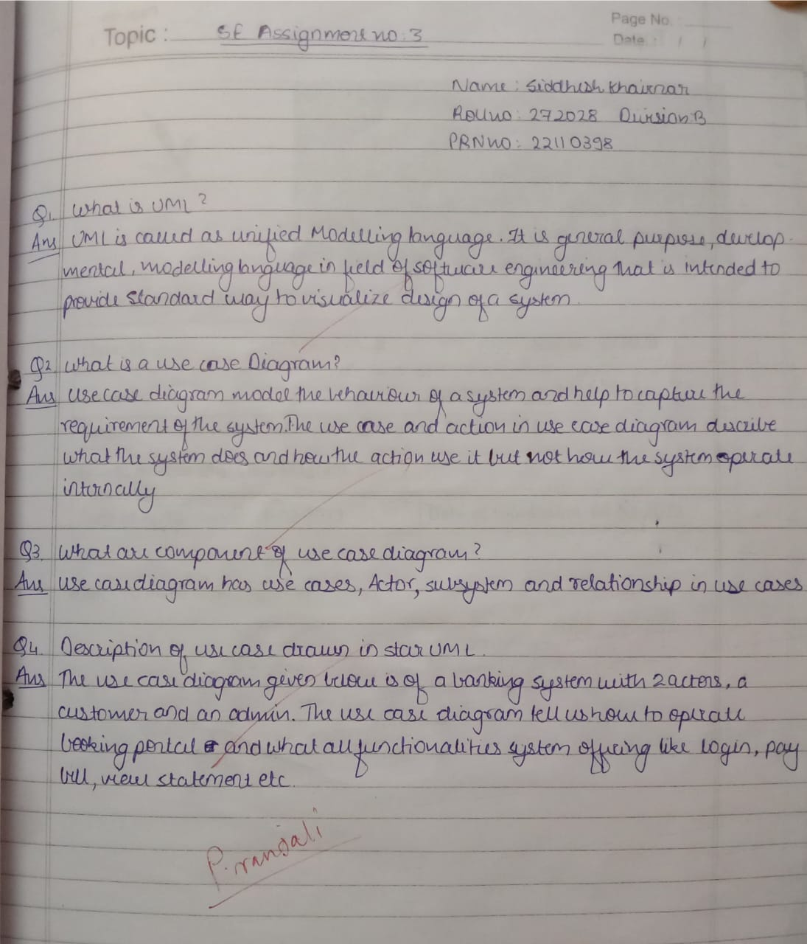

Requirements: Star UML.

Use Case Diagram:

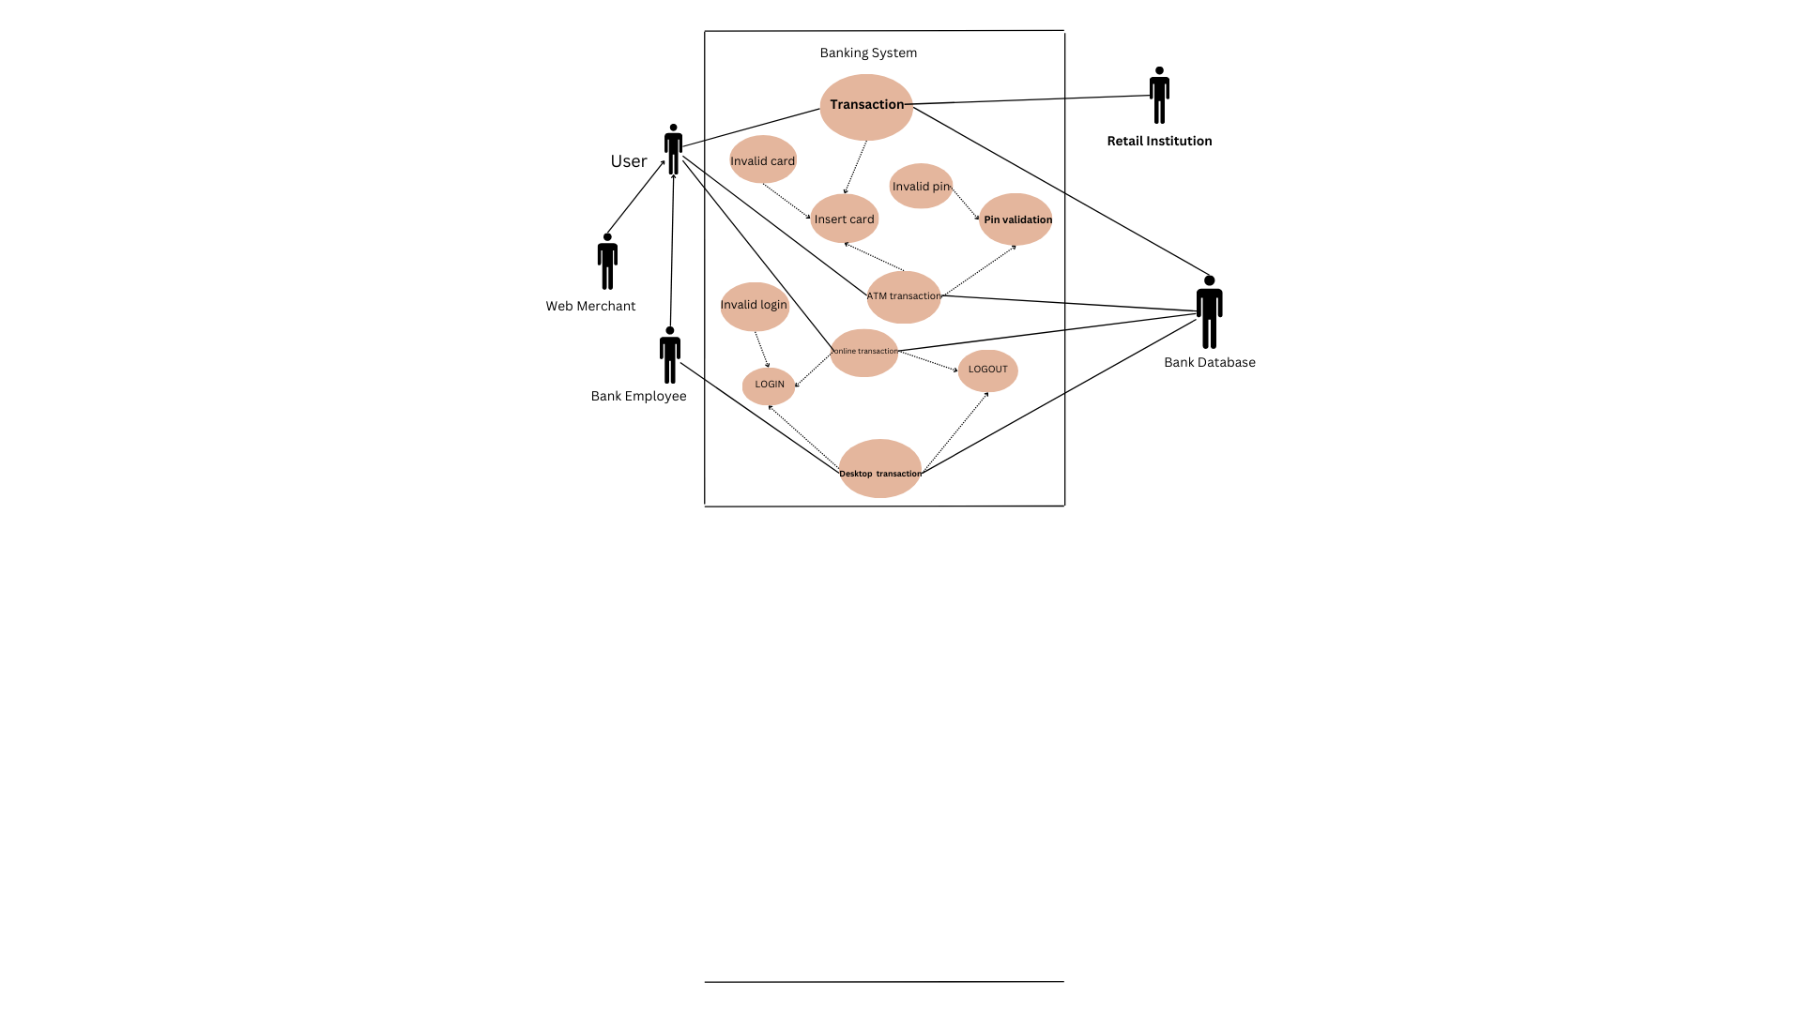

Conclusion:Hence, we have successfully implemented a use case diagram.